# ML Hands-on Assessment

## Eeshita Deepta, 654982

Downloading dataset

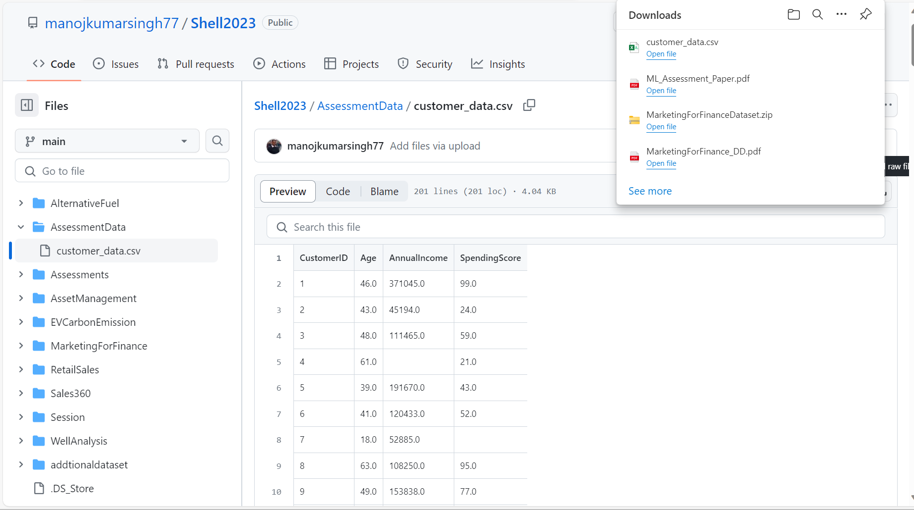

Creating Azure Machine Learning Workspace

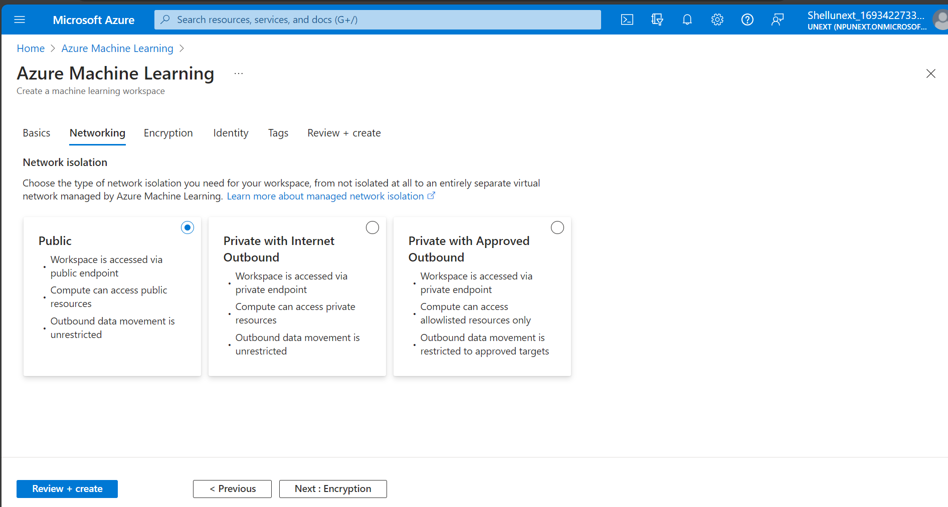

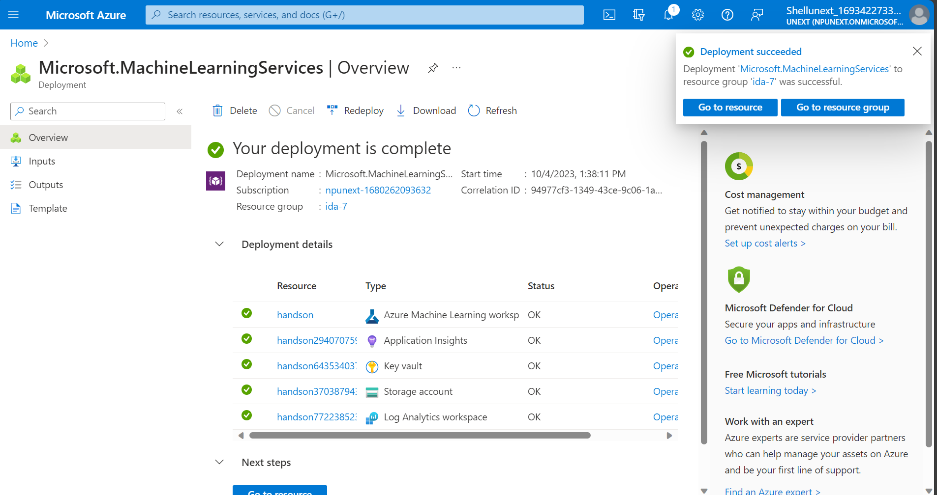

Putting data into blob storage

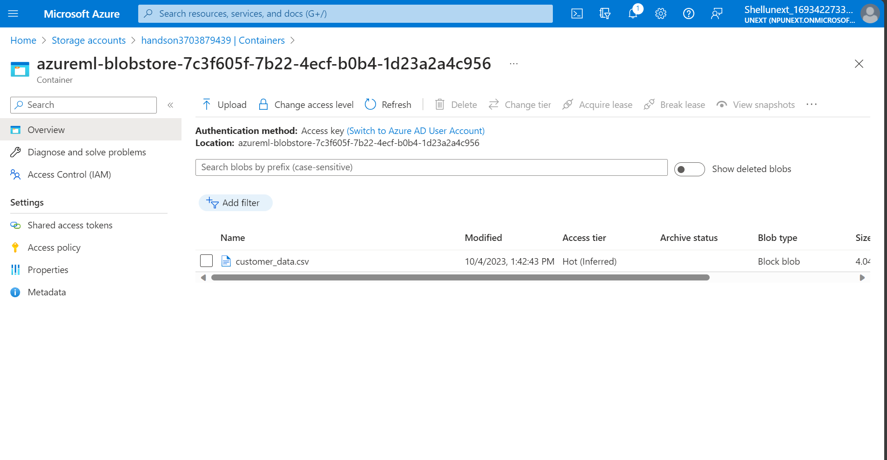

Creating data asset from blob storage

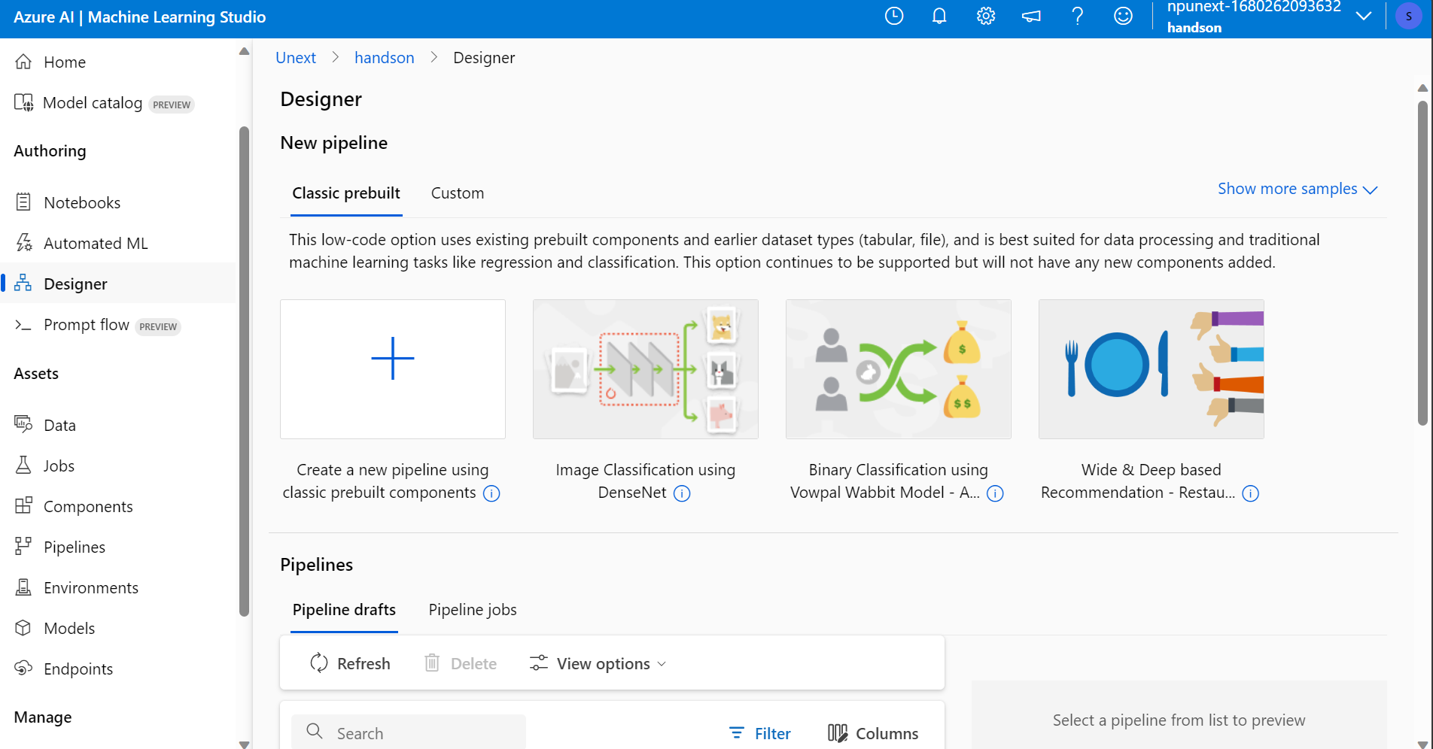

Preprocessing data

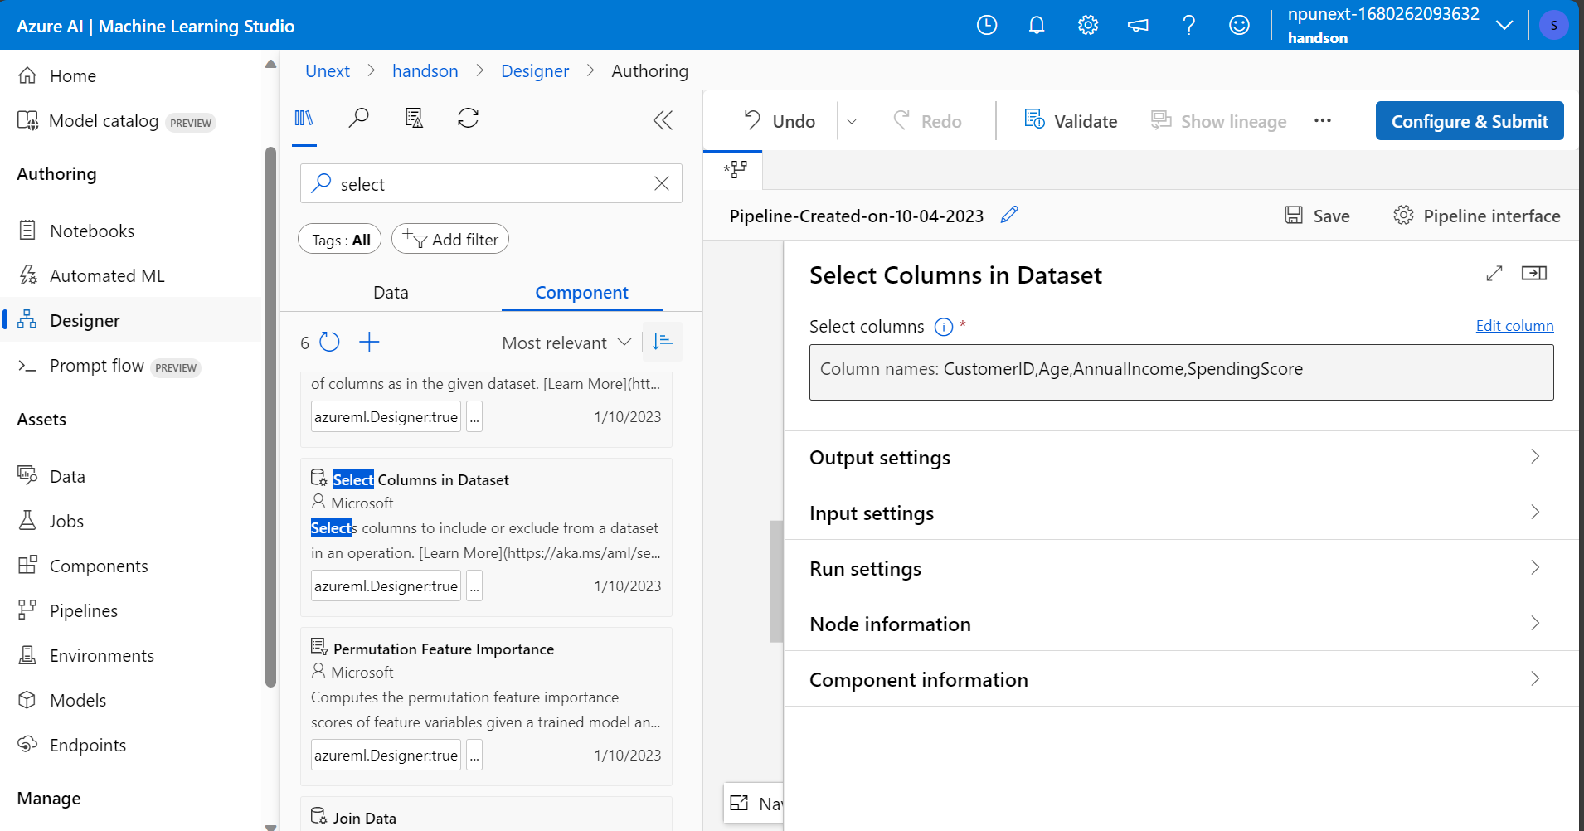

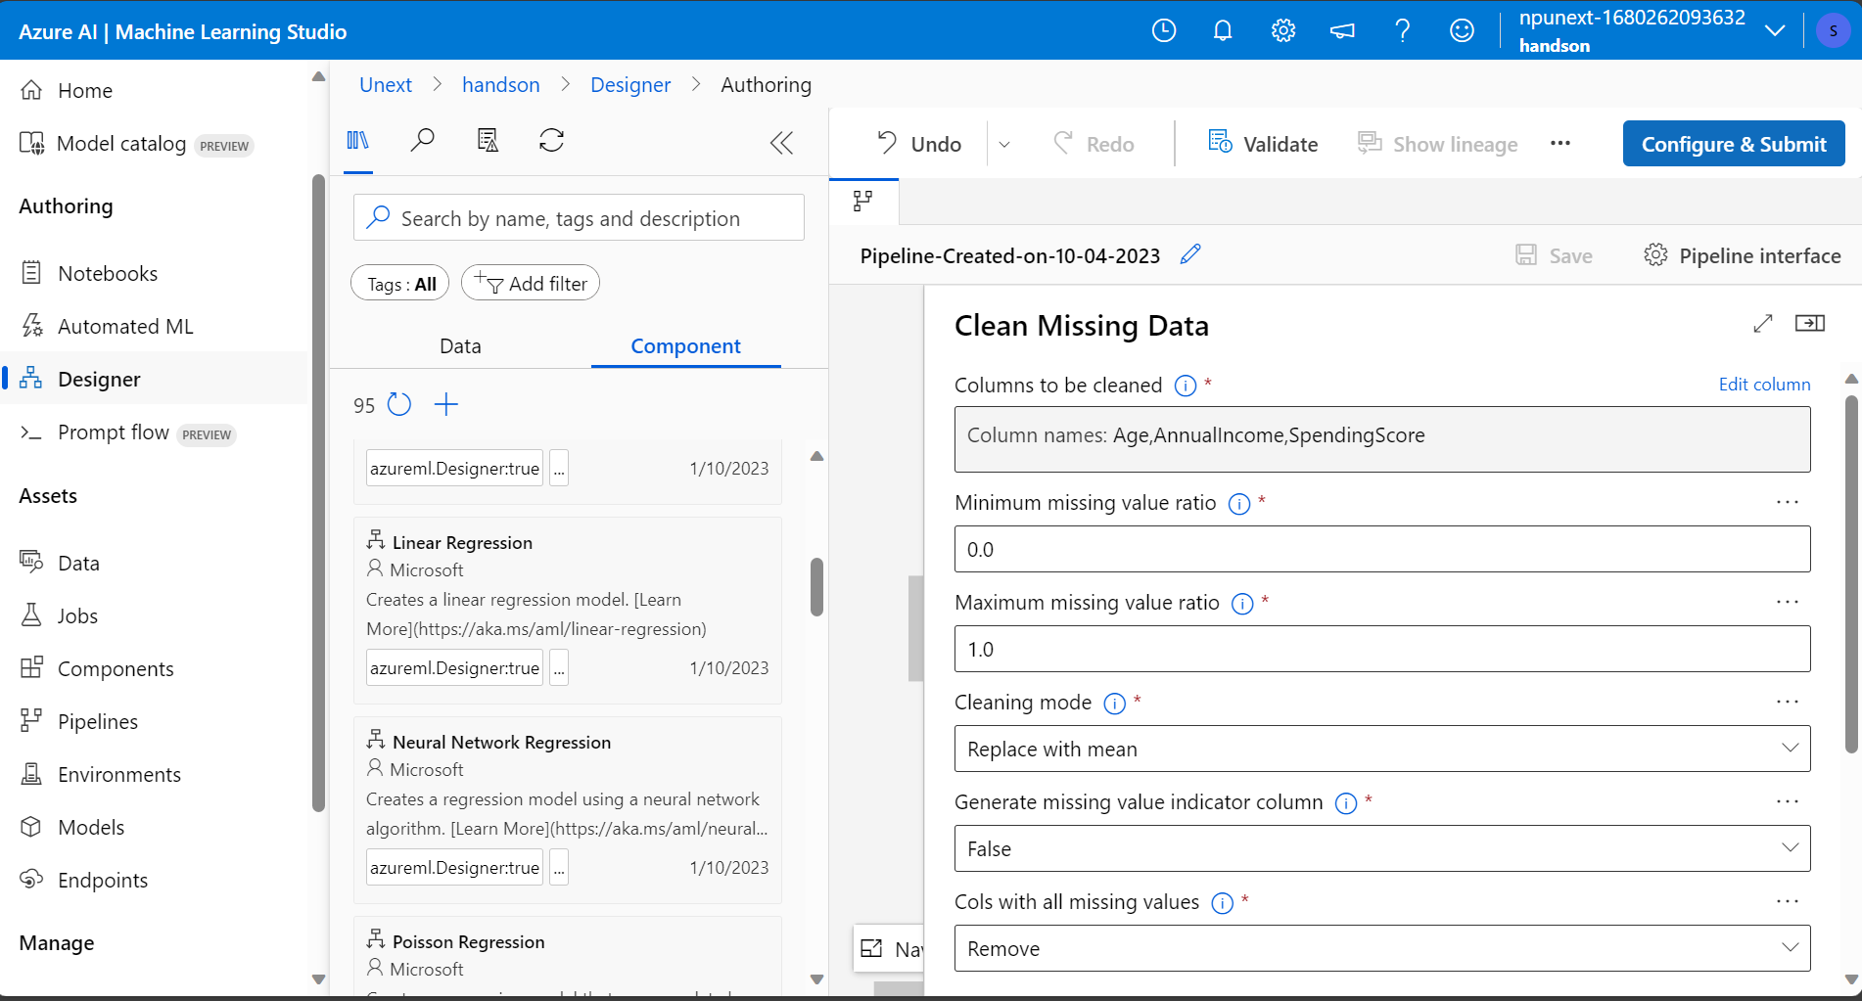

Splitting data into training and testing

Hyperparameter Tuning

Training, Scoring and Evaluating Model

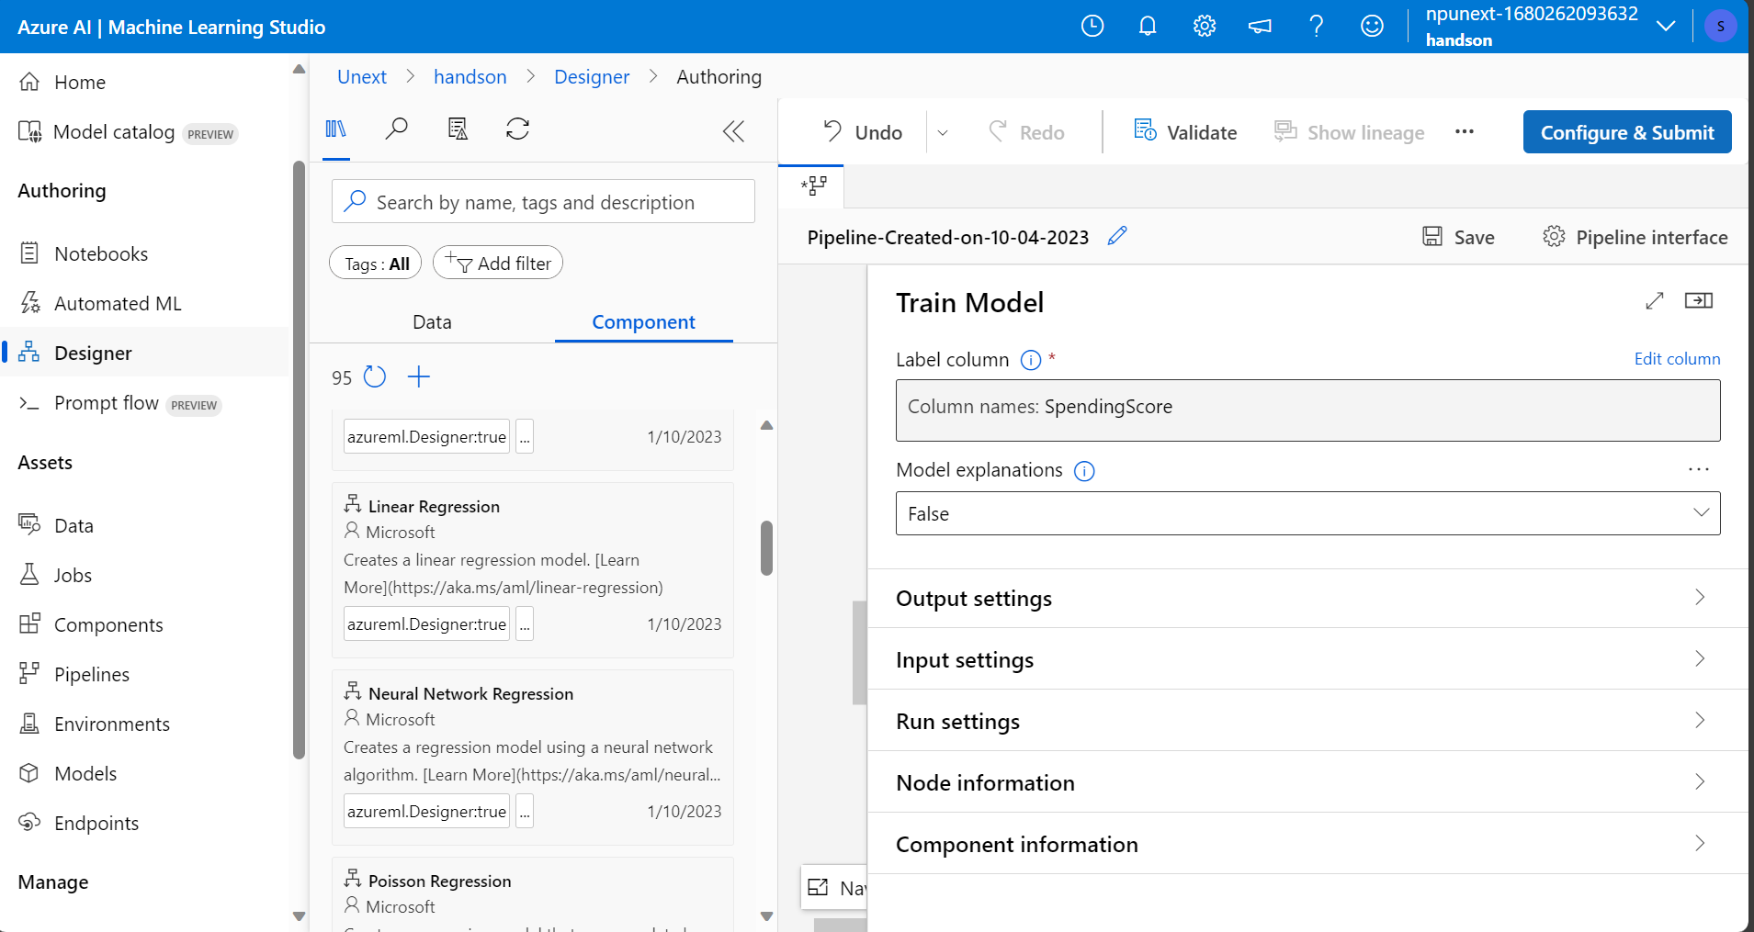

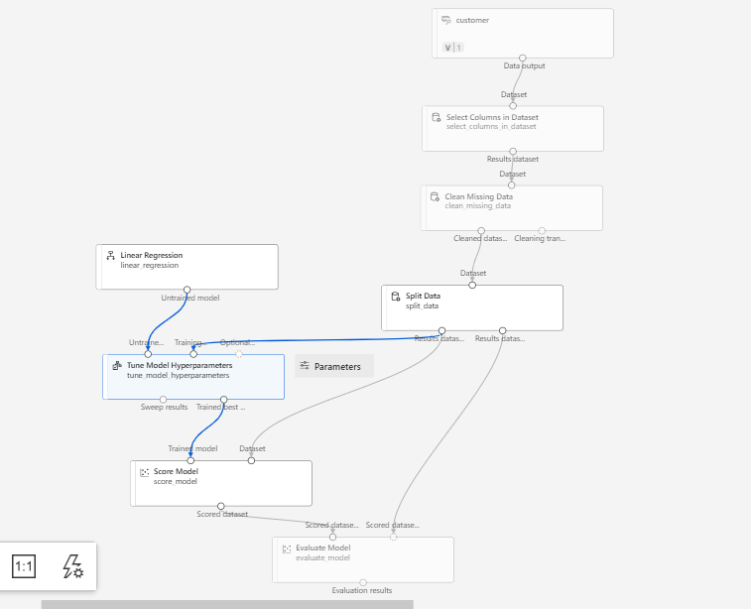

Creating compute cluster

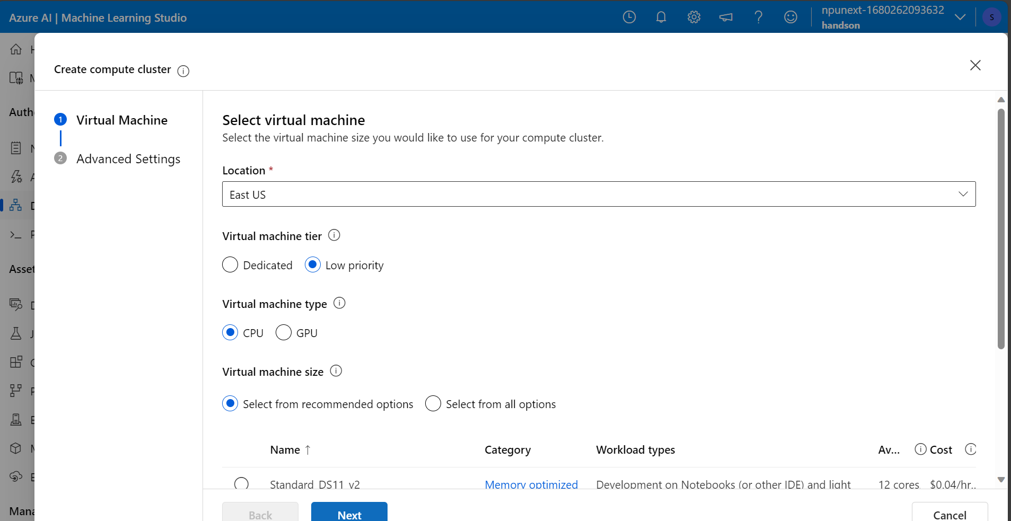

Configure and Submit

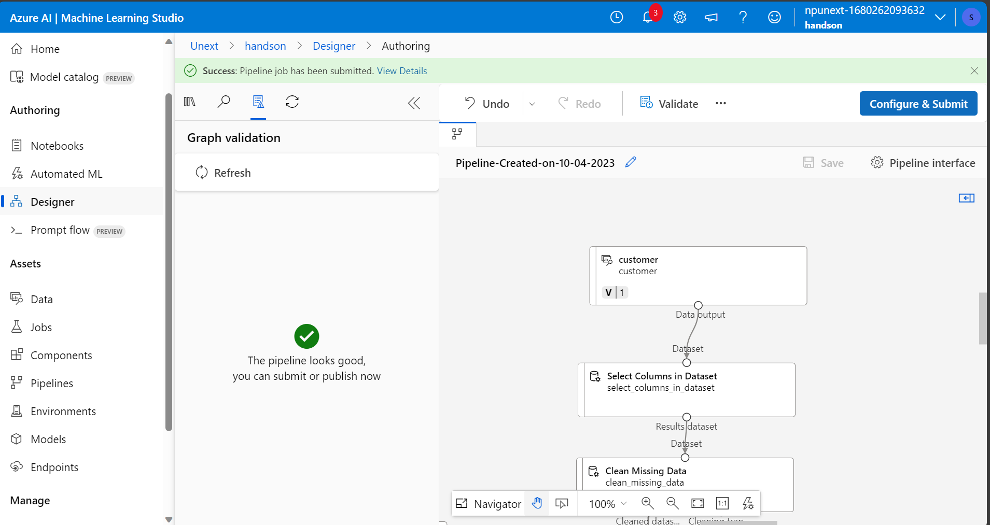

Evaluating Model

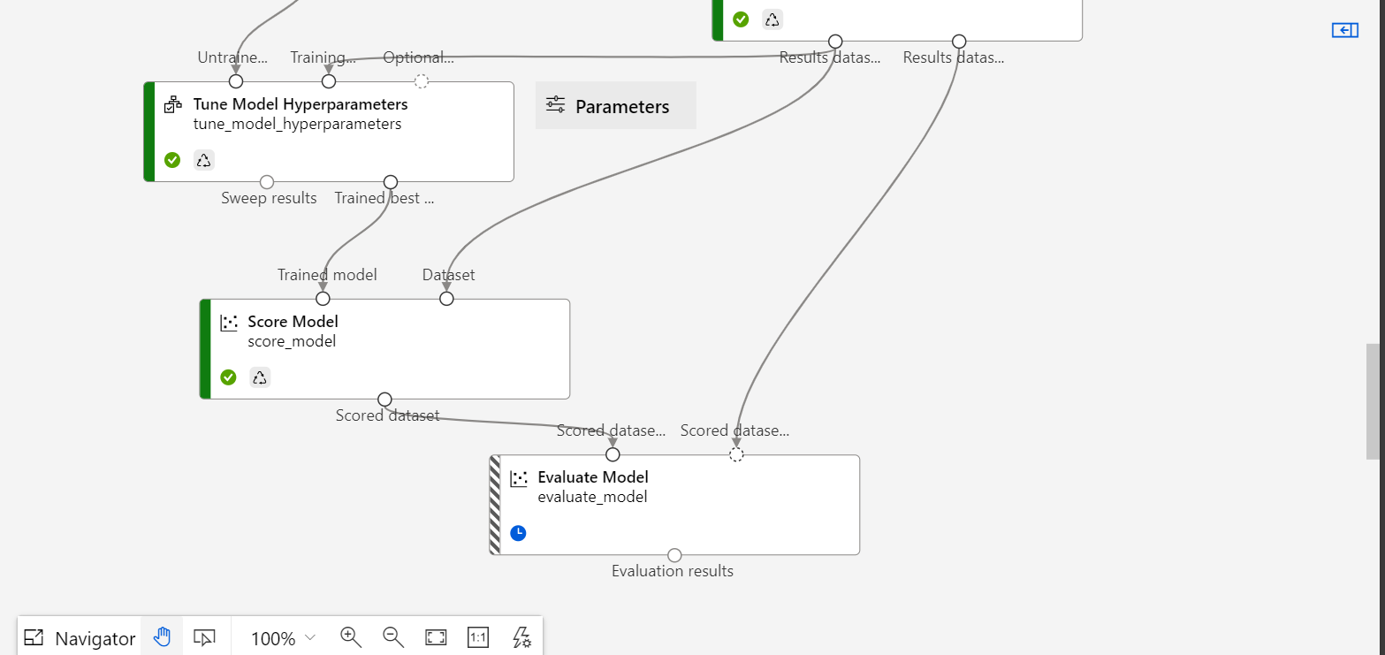

1. What are the key steps involved in preparing the dataset for training a machine learning model using Azure Machine Learning? Briefly explain each step.

The key steps involved are data ingestion, data cleaning, splitting the data, selecting the model, training the model, scoring the model and evaluating the model.

In data ingestion, the data is put from the source to the pipeline. In data cleaning, the missing values are wither removed or replaced. In splitting the data, we split it into training and testing dataset. We select the model, which is linear regression here.

There is training, scoring and evaluating the model which uses training dataset to train the untrained model while evaluation is done using unseen test data.

1. Why is it important to split the dataset into training and testing sets when developing a machine learning model? How does this help in model evaluation?

This is because the model needs to be tested on unseen data in order to make sure that it generalizes well and there is no problem of overfitting or underfitting.

1. Describe a machine learning algorithm suitable for predicting customer purchasing behaviour in the given scenario. Explain why you chose this algorithm.

Here, we can use Linear Regression to predict customer purchasing behaviour as the classification is not binary. We need a number as the output which is the SpendingScore. This is where Linear Regression is helpful. Linear regression analysis is used to predict the value of a variable based on the value of another variable.

1. What is hyperparameter tuning, and why is it important in machine learning? Explain a technique used for hyperparameter tuning and its benefits.

Hyperparameter tuning allows data scientists to tweak model performance for optimal results. This process is an essential part of machine learning, and choosing appropriate hyperparameter values is crucial for success. For example, learning rate is a hyperparameter.